**Evaluating the Credit Strength of Companies**

Altman Z-score Approach

Altman Z-score can be used to gauge the credit-strength of a company.

**Z**-**Score** of < 1.81 represents a company in distress. **Z**-**Score** between 1.81 and 2.99 represents the “caution” zone. **Z**-**Score** of over 3.0 represents a company with a safe balance sheet.

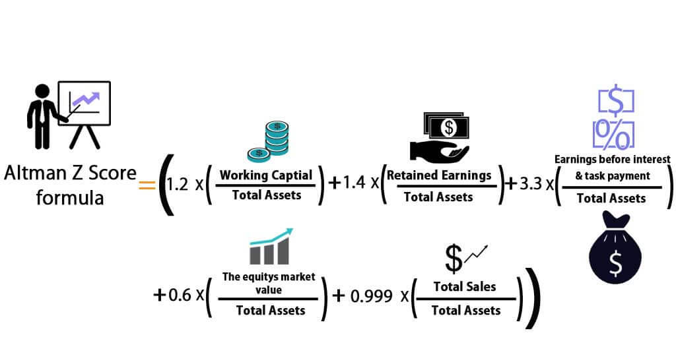

Variables required (from Company’s Balance Sheet):

* Working Capital
* Total Assets
* Retained Earnings
* Earnings before Interest and taxes
* Market Value Equity
* Book Value of Total Liabilities
* Total Sales

Machine Learning Approach

Variables required:

* Housing
  + Rent? Own?
* Years in Business
* Size of Company
* Amount
* Debt
* Loan (Secured or Unsecured)
* Variables from above can also be used here

Classification algorithm to output 0 or 1 –

* 0 represents unwise to issue out loan to company
* 1 represents OK to issue out loan to company